**GitHub:**

Installation:

[Working with GitHub in Visual Studio Code](https://code.visualstudio.com/docs/editor/github)

Tutorial Series:

[Github & VS Code - YouTube](https://www.youtube.com/playlist?list=PLpPVLI0A0OkLBWbcctmGxxF6VHWSQw1hi)

**How to Set up React-Native-Expo** (setting up emulator tutorial included in this video):

<https://www.youtube.com/watch?v=oorfevovPWw&ab_channel=notJust%E2%80%A4dev>

**Software Requirements:**

Visual Studio Code Download Site: <https://code.visualstudio.com/download>

Node.js Download Site: <https://nodejs.org/en/download/>

Android Simulator: <https://developer.android.com/studio>

Optional: (Use “Expo Go”) on mobile device to also see changes live in your app real time using the QR Code provided after ‘npm start’ command

Additional Resource for creating react app command: <https://reactnative.dev/docs/environment-setup>

**React-Native-Expo Commands:**

**Start Server**: Npm start

**Run Android Simulator**: Npm run android

React-Expo App Development Resource:

<https://docs.expo.dev/>

https://reactnative.dev/docs/getting-started

**Buttons**: 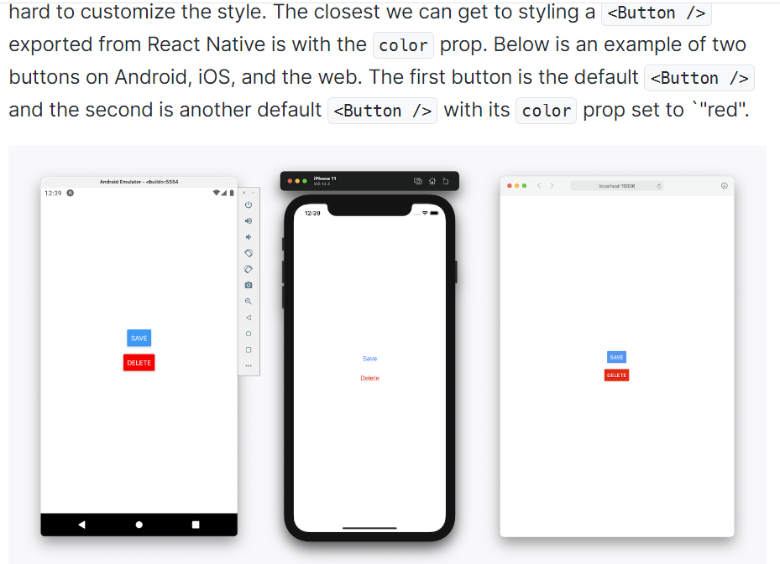

**Navigation:** (Go from one page to the next)

<https://reactnavigation.org/docs/getting-started>

**Styling:**

<https://reactnative.dev/docs/text-style-props>

<https://developer.mozilla.org/en-US/docs/Web/CSS/justify-content>

**Colors:**

<https://reactnative.dev/docs/colors>

**Header Button Navigation Solution:** <https://stackoverflow.com/questions/64195199/how-to-navigate-to-other-pages-with-header-buttons-in-react-navigation>

**Button Alert:** <https://reactnative.dev/docs/alert>

**How to Make a Call Function in React-native App**

<https://www.youtube.com/watch?v=Zvr3Kbdkm34>

<https://stackoverflow.com/questions/51545064/how-to-make-phone-call-in-react-native>

**For Loop**

<https://stackoverflow.com/questions/34648738/loop-in-react-native>

<https://thewebdev.info/2022/02/18/how-to-loop-and-render-elements-in-react-native/#:~:text=To%20loop%20and%20render%20elements%20in%20React%20Native%2C%20we%20can,the%20JavaScript%20array%20map%20method.&text=to%20call%20arr.,can%20identify%20the%20rendered%20components>.

https://www.upbeatcode.com/react/how-to-write-for-loop-in-react-js/

**Input Box:**

<https://docs.expo.dev/versions/latest/react-native/textinput/>

**AWS Amplify:**

How to install AWS Amplify with react-native (node.js software is needed as well):

Note: This link has not been officially approved to integrate AWS Amplify with React-Native

<https://docs.amplify.aws/start/q/integration/react-native/#what-well-build>